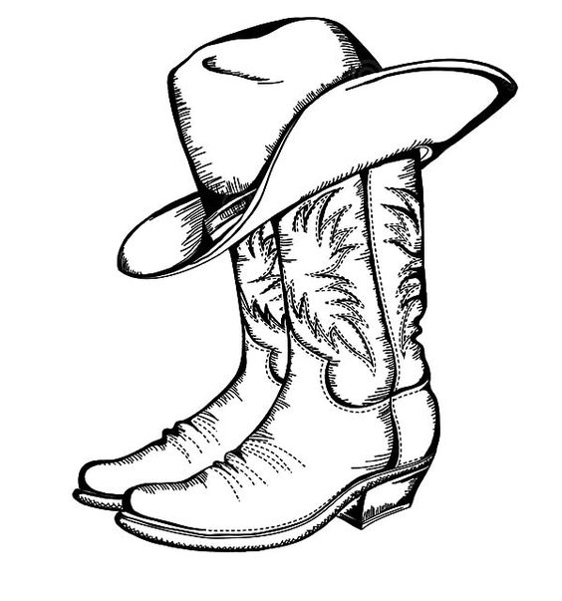
HAMEL LIONS RODEO PARADE ENTRY FORM
PARADE SUNDAY JULY 9TH, 2023
PARADE START TIME 2PM~LINE UP AT 1PM

Group Name:____________________________________________________________

Type of float: Truck/Trailer Marching Dance Horse Automobile

Length of float (ft.):________________

Contact Person:________________________________________________________________

Address:_______________________________________________________________

City:_____________________ State:_________ Zip:____________

Email:_________________________________________________________________

Phone Number:________________________

**A minimum tax deductible $20 per float donation is the suggested, please make checks payable to Hamel Lions.

WAIVER OF LIABILITY RESPONSIBILITY:

We/I ____________________________________, waive liability responsibility from the Hamel Lions Rodeo Parade Committee, the Hamel Lions and all other organizations involved from any injury sustained in conjunction with the Hamel Lions Rodeo Parade.

Authorized Signature:_____________________________________________________

Email this form to: hamelparade@gmail.com or mail to:

Hamel Lions Rodeo Parade
619 Hamel Road
Hamel, MN 55340
LINE UP INFORMATION WILL BE EMAILED THE WEEK OF THE PARADE

Any questions call Katie 612-636-1912, Kim 612-508-4962 or Deb 612-751-8215

